|  |  |
| --- | --- |
| **Ivey Publishing Logo** | **National University of Singapore Logo** |

9B21N008

GREENPAC SINGAPORE: DOING GOOD IN A SUSTAINABLE WAY

Weina Zhang, Samantha Sue Yen Ho, Lorraine Chian Wey Tan, Mengjing Xu, and Chunyu Yang wrote this case solely to provide material for class discussion. The authors do not intend to illustrate either effective or ineffective handling of a managerial situation. The authors may have disguised certain names and other identifying information to protect confidentiality.

This publication may not be transmitted, photocopied, digitized or otherwise reproduced in any form or by any means without the permission of the copyright holder. Reproduction of this material is not covered under authorization by any reproduction rights organization. To order copies or request permission to reproduce materials, contact Ivey Publishing, Ivey Business School, Western University, London, Ontario, Canada, N6G 0N1; (t) 519.661.3208; (e) cases@ivey.ca; www.iveycases.com.

Copyright © 2021, National University of Singapore and Ivey Business School Foundation Version: 2021-10-22

Among the many awards and pictures on the achievement wall at Greenpac (Singapore) Private Limited (Greenpac), one stood out for chief executive officer (CEO) Susan Chong: a photograph taken two years earlier, in 2017, that captured the moment that Chong received the President’s Award for Volunteerism and Philanthropy from Singapore’s president. The award acknowledged Greenpac’s commitment to corporate social responsibility (CSR).

Over the years, Chong had ensured that her company was an active contributor to the community. She sourced meaningful causes for her company to advocate and she sought to instill a giving attitude among her employees.

In 2019, with the company just passing its 17th anniversary and with the annual strategy review coming up, Chong wondered how she would be able to bring Greenpac’s CSR efforts to the next level. She tasked Grace Low, the executive officer and head of the CSR team, to evaluate the current CSR efforts and suggest future strategies to be considered in the upcoming annual review.

Greenpac’s BACKGROUND

Greenpac was a Singapore-based, small and medium-sized enterprise (SME) dedicated to offering innovative and environmentally friendly packaging solutions. Chong was inspired to start Greenpac in 2002 when she observed first-hand the excessiveness in the traditional packaging business.

Over the years, Greenpac had expanded its core business activities of providing packaging solutions to include heat treatment services, logistics and kitting services, and cold chain solutions. Kitting involved packaging two or more products for shipment in one kit to save costs without compromising the protection feature in the kit. Cold chain solutions were specialized services that maintained goods such as drugs and medical supplies within specific temperature bands during storage and transportation.

What started as a one-woman company became a 50-person strong, multimillion dollar company that served many blue-chip firms across different industries, such as semiconductor, electronic, medical, and pharmaceutical sectors. The company remained successful by providing cost-saving, high-quality, reliable, and innovative solutions for its customers in the packaging industry.

The core of Greenpac’s vision and mission was to be environmentally sustainable in its business operations and with the innovative solutions it offered (see Exhibit 1). One example of Greenpac’s products was a tote bin that could be collapsed and stacked and had an estimated 10-year shelf life. The bin was also reusable, returnable, and recyclable. In addition, the collapsible feature saved storage space, leading to optimized warehousing capabilities and reduced packaging waste to protect the environment.

Greenpac’s commitment to the environment was further exemplified through its careful selection of suppliers to ensure sourced materials were sustainable. For instance, for its “Revolutionary System Concept Packaging,” Greenpac sourced materials from the Forest Stewardship Council, a forest certification program supported by major environmental groups.[1] Greenpac’s decision to construct a solar-powered factory with a 50 per cent clean energy supply—the Greenhub—also served as a testimony to the company’s commitment to the environment. Greenpac carefully measured and monitored Greenhub’s carbon footprint during its construction in 2010–2011, making it the first SME industrial building in Singapore to have been built with those considerations.

GREENPAC’S CSR INITIATIVES

Similar to its core business activities, Greenpac’s CSR initiatives also emphasized conserving the environment. The CSR initiatives were framed by three thrusts: community engagement, environmental stewardship, and responsible entrepreneurship (see Exhibit 1). Despite having limited resources, Chong was passionate about making a difference in society by actively involving her company in numerous CSR initiatives (see Exhibit 2). Chong explained:

It is about taking steps and not being put off by its scale. These small steps will grow progressively as the business grows too. SMEs should not allow their limited resources to deter them from achieving a greater good. They could begin with volunteerism first and slowly work their way to explore other avenues when they gain more resources.

Green CSR Initiatives

CSR initiatives at Greenpac stayed true to the three thrusts with its efforts to raise awareness about and impart sustainable practices. According to Chong,

We are a “green” organization that is constantly seeking environmentally friendly raw materials for our innovative packaging solutions, and we believe in using sustainable resources without compromising the future generations’ needs. Thus, we are all set on driving CSR programs and initiatives that are environmentally friendly and sustainable.

One such initiative was the “GreenGives” event, which encouraged the reduction of consumer waste through the reuse of items. The initiative engaged Greenpac employees in donating and exchanging their used items, sorting and packing the donated items, and operating booths. The donated items were also distributed to the Salvation Army Singapore, an evangelical charitable organization providing community services to the needy,[2] and to some local and international schools and other beneficiary organizations. Salpac (S) Pte. Ltd., one of Greenpac’s close business partners, also participated in the GreenGives program in recent years.

Another CSR initiative unique to Greenpac was the maintenance of its own hydroponics farm, which was tended by Greenpac employees. The initiative was developed to cater to employee interests and was named “Hydroponics” by staff, for staff. In sharing this activity beyond its premises, Greenpac had sponsored hydroponics farming systems for Juying Primary School, Jurong Secondary School, and community gardens. The extended projects sent trained Greenpac employees to coach the partners (including teachers and students) on how to use the systems. The initiative provided opportunities for all participants to experience the challenges of growing vegetables, subsequently making them more mindful of food wastage issues. The harvests from Greenpac and the Juying Primary School were distributed by students and Greenpac volunteers to underprivileged households identified by a local resident committee.

Moreover, Greenpac’s green CSR initiatives had extended far beyond its internal activities. To advocate for greater environmental awareness among its external stakeholders and the public, Greenpac often shared its green practices through organized learning journeys in the Greenhub, presenting the innovative, economic, and environmentally friendly packaging solutions Greenpac developed. Participants in Greenpac’s learning journeys included local governmental agencies, the High Commission of Malaysia, prominent business associations, entrepreneurs, and many educational institutions.

Chong had frequently been invited by organizations and government partners to share her experiences in running a green company and to educate about the importance of sustainability. For instance, she was invited to become one of the 30 prestigious members of the Committee on theFuture Economy, an advisory group to the government’s Future Economy Council. The committee, chaired by the Singapore finance minister, was created in 2015 to brainstorm new and creative ways to ensure the sustainable growth of Singapore’s economy.[3]

Other CSR Initiatives

I think everyone should be given a chance if they want to be a better person today... It doesn't matter what is their background, so long as everyone wants to contribute and be a better person, I think we should encourage that.

Susan Chong

Greenpac strongly believed in equal employment opportunities and was an active champion of Singapore’s Yellow Ribbon Project. The project was spearheaded by the Community Action for the Rehabilitation of Ex-Offenders (CARE) Network in Singapore to advocate for a second chance for former convicts.[4] As of 2019, Greenpac had hired and trained four former convicts, equipping them with the relevant skills to make a living.In a similar vein, Greenpac outsourced kitting jobs to inmates and showed support by purchasing *Nonya kueh*, a type of Malay cake, made by inmates.

Greenpac was also involved in internship initiatives. The company hosted interns for work experience from secondary schools, junior colleges, and polytechnic institutions to impart knowledge, equip them with skills, and educate them on sustainability practices.

Greenpac’s Forward-Looking CSR Policies

Singapore faced severe challenges from global warming, such as heavy rainstorms, rising sea levels, and temperatures that were rising twice as fast as those in other parts of the world, at around 0.25 degrees Celsius per decade.[5] In response to these climate shifts, Singapore was taking progressive steps to build a sustainable and energy-efficient nation through Singapore’s Zero Waste Master Plan and, starting in 2019, the implementation of a carbon tax on corporations.[6]

In line with its commitment to sustainability, Singapore Exchange (SGX) had required that all publicly listed companies to prepare an annual sustainability report on a “comply or explain” basis from June 2016 onward.[7] With this mandate, public companies had to take full responsibility for their environmental, social, and governance (ESG) practices and evaluate their future prospects by reporting critical risk factors and opportunities.[8]

Greenpac was on track with the nation’s growing emphasis on sustainability. In addition to being a sustainable business, many of its CSR initiatives were conducted with the goal of environmental and social sustainability. To ensure that all employees were involved, Greenpac mandated a minimum of six hours of participation in CSR initiatives per year from the start of 2019, and this new policy would be reviewed on an annual basis. The fulfillment of the six-hour requirement would contribute to 6 per cent of the year-end employee performance appraisal. Human resource personnel communicated the new appraisal policy to all employees in 2018 via email and office notices. If employees decided to participate in CSR initiatives during office hours to fulfill the six-hour obligation, they were given paid leave to do so.

MEASURING GREENPAC’S CSR EFFORTS

With Greenpac at the forefront of advocating and carrying out sustainable business practices and corporate-giving activities in Singapore, Low needed to understand which CSR areas Greenpac had done well in and how the company could be further improved.

To conduct a preliminary assessment of Greenpac’s CSR efforts, Low reached out to a group of consultants for suggestions. Since no assessments had previously been done for Greenpac’s CSR efforts, the consultants recommended three frameworks for her evaluation, which would allow Low to compare Greenpac’s efforts against that of other companies: (1) the National Volunteer and Philanthropy Centre (NVPC)’s 4 I’s framework to assess how well Greenpac had been giving; (2) the Governance Metrics International (GMI) ESG Ratings; and (3) the Global Reporting Initiative (GRI) framework adopted by the Centre for Governance, Institutions and Organizations (CGIO).

4 I’s Framework[9]

NVPC was a Singapore-based, non-profit organization that launched the Company of Good program in 2016 with the support of the Ministry of Culture, Community and Youth. The program aimed to empower businesses in Singapore to give in strategic, sustainable, and impactful ways using a framework that evaluated four aspects of corporate giving: investment, integration, institutionalization, and impact: the 4 I’s (see Exhibit 3).

With Greenpac being one of the companies in the Company of Good network, Low was familiar with the framework. Investment measured how extensively and strategically a company gave. Integration examined whether a company’s corporate-giving activities were integrated with the business functions and supported business interests. Institutionalization analyzed whether the company had policies, systems, and incentives in place to support corporate-giving initiatives. Impact assessed how mechanisms had been put in place to measure the impact of a company’s CSR efforts.

GMI ESG Ratings[10]

GMI Ratings was an internationally recognized provider of ESG ratings, with 150 ESG key metrics that measured the sustainability performance of public companies by looking through their annual reports, regulatory filings, websites, and news articles (see Exhibit 4).

Greenpac was a private company with limited information disclosed to the public; therefore, the consultants obtained most of the information from Greenpac’s internal documents and interviews with the management team. Because Greenpac had received numerous awards from the Singapore government and many international agencies since its inception in 2002, the company had prepared plenty of official documents as a requirement of being awarded. Hence, the consultants mainly relied on these submitted documents for their evaluation. Moreover, Chong had been a frequent public speaker at various schools and public media. Hence, the information disclosure from Greenpac would be considered equivalent to, if not more than, the usual public disclosure made by publicly listed firms. Consultants used the information to produce a score for Greenpac that was comparable to the score that publicly listed companies would make.

CGIO’s GRI Framework[11]

The GRI framework was used to assess companies’ level of disclosure in the following categories: (1) reporting principles and governance (overall drivers) and (2) economic, environmental, and social aspects (EES) (see Exhibit 5). The objective was to encourage greater transparency and, thus, commitments in the company’s sustainability practices. Similar to GMI Ratings, CGIO’s GRI framework was used to rate public companies; therefore, the consultants proposed the score that Greenpac could have achieved had it disclosed such information to the public.

The consultants provided Low with an evaluation for each of the three frameworks (see Exhibits 3–5). With the results at hand and some pros and cons that she had identified for each framework, Low began to assess the results and decide which was the most appropriate framework to use.

RECENT EMPLOYEE ENGAGEMENT SURVEY OF CSR

To gather additional insights to improve the current CSR initiatives, Low obtained feedback from the participants in Greenpac’s CSR initiatives—the employees—using an anonymous survey she designed. Specifically, Low was interested in identifying the drivers behind employee participation in CSR initiatives, employee experiences with the CSR initiatives, and any suggestions that they might have.

In addition, Low designed a survey section dedicated to Greenpac executives, which included senior level employees and the heads of departments. The objectives were to understand executives’ attitudes toward CSR initiatives and their respective departments’ engagement in CSR initiatives, and, finally, to gather insights on approaches that executives could use to enhance employee engagement in CSR initiatives.

Employee Engagement Survey Results

Low observed a few general trends regarding the level of employee engagement in Greenpac’s CSR initiatives. Employee experience with Greenpac’s CSR initiatives showed an average satisfaction score of 3.75 out of 5. She also found that 81.8 per cent of employees were willing to spend six or more hours on CSR initiatives in a year, and 52.8 per cent of employees indicated their interest in participating in CSR initiatives on weekends. Additionally, Low noticed that two CSR initiatives, involvement in internships and GreenGives, were preferred the most by the employees for repeated engagement at 90.9 per cent and 89.5 per cent, respectively.

After performing a further in-depth analysis, Low realized that only 8.3 per cent of employees had made suggestions regarding the company’s CSR efforts. This small group of employees were found to have scored better than those who did not make suggestions in three aspects: rate of participation in external CSR initiatives, willingness to do more good, and general experience with Greenpac’s CSR initiatives (see Exhibit 6.1). A similar trend was observed among employees who were aware of the Greenpac’s CSR team; they scored higher than those who were not aware of the CSR Team in the same three aspects (see Exhibit 6.1).

The survey results highlighted one key challenge faced by Greenpac: as an SME with a lean organizational structure and small teams, involving everyone in the organized CSR initiatives was difficult because some employees had to be at their desks or workstations during working hours to facilitate the smooth running of the company (see Exhibit 6.2).

Low also recognized that the two most popular suggestions (50 per cent) made by employees to improve the CSR initiatives were to have more bonding opportunities with colleagues in these initiatives and to increase the variety of CSR initiatives. Further, Low noticed that employees who had a positive experience and those who were willing to commit more hours in CSR initiatives had higher work satisfaction and better work motivation (see Exhibit 6.3).

Executive Survey Results

Low designed an additional section in the survey for executives to complete with the aim of discovering how executives managed and encouraged their subordinates’ participation in CSR initiatives. Specifically, Low wanted to find out which approaches used by the executives were the most effective inachieving a higher level of employee engagement in CSR initiatives, and which approaches were the mostpractical or the easiest for executives to deploy to employees.

The survey results revealed that, in general, the effective approaches adopted by executives included “recognizing and rewarding employee contributions” and “educating about the importance of CSR.” The results also showed that executives found it easiest to release the employees for CSR activities if the employees were interested in the activities and they were recognized and rewarded for their contribution (see Exhibit 7).

MOVING FORWARD

With the information she gathered from the consultants, the survey results, and her additional research, Low had two primary questions to address: Which framework would serve Greenpac best in evaluating its CSR efforts? How could Greenpac better engage its employees in CSR initiatives?

With the annual strategy review pending, Low reviewed some memorable pictures taken at past CSR activities (see Exhibit 8) and began to brainstorm how best to synthesize all of the information into the actionable suggestions Chong needed for continuing Greenpac’s CSR journey.

EXHIBIT 1: GREENPAC’S VISION, MISSION, AND THREE THRUSTS FRAMEWORK

**Vision:** “We strive to be a world-class knowledge-based company that offers total and innovative environmentally friendly packaging solutions.”

**Mission:** “We partner with our customers to re-engineer their industrial packaging processes by creating innovative and environmentally friendly packaging solutions to achieve bottom-line savings and supply chain efficiency.”

**The CSR Three Thrusts:** Greenpac uses three thrusts (community engagement, environmental stewardship, and responsible entrepreneurship) to guide its CSR initiatives.

**Review**

**Platform**

Senior Management Meeting

Greenpac’s Vision, Mission, and Core Values

Community

Engagement

*Doing good and*

*doing well*

Environmental Stewardship

*Leading the way to conserve and preserve our workplace and environment*

Responsible Entrepreneurship

*Forging partnerships with stakeholders and communities to improve knowledge and intellectual standards*

**Strategies**

Leadership, Communication, Participation, Awareness, Facilitation

**Systems/Schemes/Programs**

* Green Design
* Green Label
* Zero Energy Office
* 3Rs, Eco-Office, SS587
* Friends of Water
* 5-Prong Business Philosophy
* Signatory of Singapore Packaging Agreement
* Signatory of United Compact
* IRAS Tax Act
* Labour Law
* Company Act
* Greenpac Code of Conduct and Business Ethics
* Building Act
* ISPM15, QMS, EMS
* HC Partner (Tripartite)
* Packaging Waste Reporting Program
* Earth Hour
* GreenGives
* Yellow Ribbon
* Hydroponics Sponsorship
* Learning Journey
* Internship Program
* Packaging Waste Education Program

Note: 3Rs = reduce, reuse, and recycle; EMS = Emergency Medical Service; HC =Human Capital; IRAS = Inland Revenue Authority of Singapore; ISPM15 = International Standards For Phytosanitary Measures No. 15; QMS =Quality Management System; SS587 = a new voluntary Singapore Standard for the management of end-of-life ICT (infocomm technology) equipment.

Source: Company documents.

EXHIBIT 2: DETAILS OF ONGOING CSR INITIATIVES CONDUCTED BY GREENPAC

| **CSR Initiative** | **Description of Event** | **Frequency** |
| --- | --- | --- |
| **Green CSR Initiatives** | | |
| 1. Hydroponics systems | Greenpac donates hydroponics systems to schools and resident communities to encourage environmental stewardship and self-sufficiency through growing food. Employees coach the students and residents on the use of the hydroponics system. | Depends on beneficiaries’ readiness and Greenpac’s availability of human resources |
| 1. GreenGives | Greenpac’s staff sort, pack, and distribute donated items and donate their used items in a free-of-charge internal bazaar. This bazaar is held on Greenpac’s premises. The leftover items are then donated to the Salvation Army and other beneficiary organizations. | Once or twice per year |
| 1. Earth Hour activities | Greenpac organizes a yearly month-long Earth Hour campaign with talks and activities designed to create awareness among its employees on the need to preserve the Earth’s resources. | Once a year |
| 1. Learning Journey | Greenpac has organized learning journey trips at Greenhub for schools, governmental agencies, and many other business organizations to share its zero-energy office and best practices for sustainability. | Minimum twice per year |
| 1. Internships with Greenpac | Greenpac has hosted interns for work experience from secondary schools, junior colleges, and polytechnic institutions to impart knowledge, equip participants with skills, and educate them on sustainability practices. | Minimum once per year |
| 1. Public talks to raise awareness | Greenpac CEO Susan Chong frequently accepts invitations by other organizations and government partners to share her experiences in running a green company and to educate about the importance of sustainability. | Whenever there is an invitation |
| **Other CSR Initiatives** | | |
| 1. Supporting the Yellow Ribbon Project | Greenpac hires former convicts to provide them with a second chance in life, and it outsources its kitting jobs to inmates. | Whenever there is a need |
| For its in-house events, Greenpac purchases Nonya kueh that is handmade by inmates and sold by an inmate-run confectionary. | Whenever there are events |
| 1. Collaboration with Lions Club of Singapore Meyer | The collaboration has organized several activities, which include making and delivering mooncakes and providing larger vans for transportation. The collaboration also includes spreading awareness at Juying Primary School about hearing damage. | Once or twice per year |
| 1. Ramadan goodie bag packing and distribution | The company packs Ramadan goodie bags and delivers them to the BizLink Muslim beneficiaries using larger vans to reduce the number of trips made. | Once a year |
| 1. Participate in the Lions Befriending Walk | Greenpac has participated in the walk to help prevent social isolation among seniors in Singapore. | Once a year |
| 1. Contribute to the National University of Singapore (NUS)’s bursary scholarship | Greenpac donates to NUS Business School's undergraduate bursary and also awards a scholarship under the SME-SPRING Joint Executive Development Scholarship program. | Once a year |
| 1. Purchase of ukuleles for Pertapis Children Home | Greenpac buys ukuleles and tuners for Pertapis Children’s Home. | Whenever there is a need |

Source: Compiled by the case authors based on company documents.

EXHIBIT 3: NVPC’S 4 I’s FRAMEWORK

|  |  |  |
| --- | --- | --- |
| **4 I’s Framework** | **Questions** | **Examples** |
| **Investment**:  How extensively and strategically a company gives | Does your company give in more than one way that is aligned to the vision, mission, strategy, or nature of your business? | Food production companies are in a better position than clothing manufacturing companies to conduct food distribution activities because they have the expertise and resources to carry out such activities. |
| **Integration**:  How giving is integrated with business functions and supports business interests | Does your business advocate a social cause or does your business procure from charities? | Companies that source products from charities or hire marginalized groups of people in society have integrated their giving activities with their business operations. |
| **Institutionalization**: How giving is supported by policies, systems, and incentives | Does your company provide paid volunteer leave or recognize outstanding employee volunteers? | Companies that give employees paid volunteer leave or recognize employees’ volunteering contributions will perform better in this category. |
| **Impact**:  How mechanisms have been put in place to measure the impact of giving | Does your company set up processes to measure the input, output, outcome, and impact of your giving? | Companies who conduct post-CSR activity feedback surveys with employees or the beneficiary organizations to measure the impact of giving will perform better in this category. |

Note: NVPC = National Volunteer and Philanthropy Centre.

Source: “About Company of Good,” Singapore Company of Good, accessed February 17, 2021, https://www.companyofgood.sg/about.

EXHIBIT 4: GMI Ratings’ ESG RATING FOR GREENPAC

GMI Ratings provides a matrix for evaluating a company’s environmental, social, and governance (ESG) activities. The framework, acquired by Morgan Stanley Capital International Inc. (MSCI) ESG Research Inc. in 2014, is used by over 6,400 companies globally.

The framework provides 150 ESG key metrics to aid companies in incorporating ESG factors in their risk assessment and decision-making. The 150 key metrics are organized into six individual scoring components: (1) board, (2) pay, (3) ownership and control, (4) accounting, (5) environmental, and (6) social. Briefly, these indicators include the conduct of directors, remuneration policies, shareholder rights, environmental impacts such as carbon emissions and waste production, and social impact of the company’s businesses in adhering to ethical business practices and labour practices.

The key metrics in the dataset are scored using a binary scoring model with negative flags, with “1” given if the company does not meet the assessment criteria of a key metric, and “0” given if the company meets it. The total score of each of the six components is calculated by summing the scores for all key metrics under that component. **As a result, a LOWER score reflects a BETTER performance**. For each component, “0” is the best score. The maximum score is given in the first row of the table below.

The following table provides Greenpac’s performance as rated by the consultants and presented relative to companies across the world.

|  |  |  |  |  |  |  |
| --- | --- | --- | --- | --- | --- | --- |
|  | **Environmental** | **Social** | **Governance** | | | |
|  | **Board** | **Pay** | **Ownership & Control** | **Accounting** |
| Possible score for the component | 0–21 | 0–33 | 0–38 | 0–23 | 0–27 | 0–8 |
| **Greenpac\*** | **0** | **1** | **5** | **2** | **1** | **0** |
| **Comparison with world average** | | | | | | |
| Average of GMI-rated firms globally | 3.5 | 7.0 | 6.1 | 4.1 | 6.5 | 0.6 |
| Firms in developed economies | 3.2 | 7.0 | 5.8 | 4.2 | 6.8 | 0.7 |
| Firms in emerging economies | 4.9 | 7.2 | 7.3 | 3.5 | 5.3 | 0.2 |
| **Comparison with Asian average** | | | | | | |
| Average of GMI-rated firms in Asia | 4.3 | 7.2 | 8.9 | 3.7 | 5.2 | 0.3 |
| Firms in developed economies | 3.3 | 6.8 | 9.7 | 3.9 | 4.9 | 0.5 |
| Firms in emerging economies | 5.5 | 7.6 | 8.0 | 3.5 | 5.5 | 0.2 |
| **Comparison with firms in Singapore** | | | | | | |
| All publicly listed firms in Singapore | 5.2 | 6.6 | 4.7 | 3.7 | 4.4 | 0.5 |

Note: *Some of the key metrics under the ESG framework were not applicable to Greenpac because Greenpac is a private firm whereas the framework is mainly applicable to publicly listed firms. The consultants took the following number of key metrics (indicated in parentheses) out of assessment as not applicable or relevant to SMEs like Greenpac: environmental (11), social (4), board (18), pay (18), ownership and control (13), and accounting (4).

Source: Compiled by the case authors based on input from Susan Chong, chief executive officer, and Grace Low, executive officer and head of the CSR team, Greenpac; ESG Indexes (database), Morgan Stanley Capital Index (MSCI), accessed January 14, 2021, https://www.msci.com/esg-indexes; and “World Economic Outlook Database, April 2018,” International Monetary Fund, accessed September 21, 2018, https://www.imf.org/en/Publications/WEO/weo-database/2018/April.

EXHIBIT 5: CGIO GRI REPORTING FRAMEWORK FOR GREENPAC

The Centre for Governance, Institutions, and Organizations (CGIO) was established by the National University of Singapore Business School to launch relevant and high-impact research on governance and sustainability issues in Asia. The centre employs an adapted version of the Global Reporting Initiative (GRI) to assess the level of disclosure in the sustainability reporting of 678 Singapore-listed companies. The data used to derive the GRI score includes public information conveyed on companies’ corporate websites and annual reports.

The scores for the GRI ratings are derived from the assignment of points on a scale of 1 to 5 for each selected GRI disclosure criterion. If no information is provided by the company for that criterion, 1 point is awarded. If the company discloses quality and detailed information relevant to that criterion, 5 points are awarded. If the criterion is not applicable to the company, the score assigned for that criterion will be 1.

The criteria are categorized into two equally weighted components: the reporting principles and governance component (overall drivers) and the economic, environmental, and social aspects of the company (EES). The reporting principles focus on the disclosure of corporate information and adoption of the GRI reporting framework. Governance focuses on the governance structure and remuneration policies of the company. The disclosure on EES includes assessing the company’s sustainability considerations in economic decision-making, practices to protect the environment, and employment practices.

The chart below displays Greenpac’s level of sustainability disclosures as rated by the consultants according to the CGIO GRI reporting framework, relative to Singapore companies in the manufacturing industry and in all industries. The maximum score for both overall drivers and disclosure on EES is 50 per cent.

Maximum: 50%

Note: The absolute score, measuring the level of sustainability disclosure, estimates the comprehensiveness of information disclosed. This score is not meant to represent the company’s actual sustainability performance. The scores for Greenpac were assigned by the case authors based on the CGIO Sustainability Index Framework highlighted in the referenced report.

Source: Lawrence Loh and Thomas Thomas, *Sustainability Reporting in Singapore* (Singapore: Centre for Governance, Institutions and Organisations, National University of Singapore Business School, November 2018), https://bschool.nus.edu.sg/cgio/wp-content/uploads/sites/7/2018/11/ACN-CGIO-Sustainability-Reporting-in-Singapore-2018.pdf.

EXHIBIT 6: KEY EXTRACTS FROM GREENPAC’S EMPLOYEE ENGAGEMENT SURVEY

(Sample size = 36 Employees)

6.1: Employees’ Satisfaction and Engagement Level with Corporate Social Responsibility (CSR)

|  |  |  |  |  |  |
| --- | --- | --- | --- | --- | --- |
|  | **Are employees aware**  **of the CSR team*?** | | | **Have employees made suggestions regarding CSR initiatives?** | |
|  | **Yes** | **No** | **Yes** | | **No** |
| % of employees | 86.1% | 13.9% | 8.3% | | 91.7% |
| 1. **Past experience with CSR in Greenpac** | | | | | |
| Positive | 67.7% | 0.0% | 66.7% | | 57.6% |
| Neutral | 29.0% | 100.0% | 33.3% | | 39.4% |
| Negative | 3.2% | 0.0% | 0.0% | | 3.0% |
| 1. **Willingness to participate in CSR initiatives** | | | | | |
| For 6 hours and more | 89.3% | 40.0% | 100.0% | | 80.0% |
| On a weekend | 58.1% | 20.0% | 100.0% | | 48.5% |
| 1. **Participation in outside volunteering initiatives** | | | | | |
| Yes | 65.3% | 20.0% | 66.7% | | 56.7% |
| No | 5.7% | 80.0% | 33.3% | | 43.3% |

6.2: Employees’ Attitude and Feedback Toward CSR**

|  |  |  |
| --- | --- | --- |
|  | **Most popular choice**  **(% of employees)** | **Second most popular choice**  **(% of employees)** |
| 1. **CSR initiatives employees are most/least keen to continue** | | |
| Most keen to continue | Involvement in internships (90.9%) | GreenGives (89.5%) |
| Least keen to continue | Learning journey in Greenpac (69.2%) | Participating in company’s Earth Hour activities (70.6%) |
| 1. **Willingness to participate in CSR initiatives** | | |
| Why willing to participate | It is the right thing to do (55.6%) | To contribute to the corporate image of the company (50%) |
| Why not willing to participate | My work responsibilities stopped me from joining in the company’s CSR during working hours (55.6%) | I had to cover the work of my colleagues who were doing CSR at that time (30.6%) |
| Suggestions on how to increase willingness to participate | CSR initiatives should contain more opportunities for bonding with colleagues (50%) | CSR initiatives could have more variety (50%) |

Exhibit 6 (Continued)

6.3: Relationship between Level of CSR Engagement and Work-Related Metrics

|  | **Work Satisfaction**  **(1–5, with 5 being the highest score)** | **Work Motivation**  **(1–5, with 5 being the highest score)** |
| --- | --- | --- |
| 1. **Past experience with CSR initiatives in Greenpac** | | |
| Positive | 3.8 | 3.8 |
| Neutral | 3.4 | 3.3 |
| Negative | 3.2 | 1.6 |
| 1. **Willingness to commit for 6 hours and more** | | |
| Yes | 3.7 | 3.7 |
| No | 3.0 | 2.8 |

Note: *Greenpac’s CSR team started as a team of three, but the team was reduced to only Chong and Low after the third person left the company in December 2018. **The percentages of employees who chose the option do not add up to 100 per cent because the survey question allowed employees to select multiple options.

Source: Compiled by the case authors based on company documents.

EXHIBIT 7: EFFECTIVENESS and PRACTICALITY OF SIX METHODS EMPLOYED BY EXECUTIVES IN ENGAGING EMPLOYEES IN CSR INITIATIVES (Sample Size = 17 Executives)

|  |  |  |  |  |  |  |
| --- | --- | --- | --- | --- | --- | --- |
|  | **Lead by example** | **Organize activities employees are interested in** | **Recognize and reward employees’ contribution** | **Educate about the importance of CSR** | **Let employees organize CSR initiatives** | **Actively ask employees to participate** |
|  | | | | | | |
| 1. **Perceived participation of employees in my department in CSR initiatives [Effectiveness]** | | | | | | |
| Active* | 50.0% | 50.0% | 70.0% | 60.0% | - | 50.0% |
| Neutral* | 50.0% | 50.0% | 30.0% | 40.0% | 100.0% | 50.0% |
| 1. **Ease of mobilizing employees in my department to participate in CSR initiatives [Practicality]** | | | | | | |
| Easy** | 25.0% | 50.0% | 33.3% | 14.3% | - | 28.6% |
| Neutral** | 75.0% | 50.0% | 66.7% | 85.7% | 100.0% | 71.4% |

Note: *No executives chose “inactive participation of employees.” **No executives chose “mobilizing employees is difficult.”

Source: Compiled by the case authors based on company documents.

EXHIBIT 8: PICTURES OF GREENPAC’S CORPORATE-GIVING ACTIVITIES

GreenGives Event

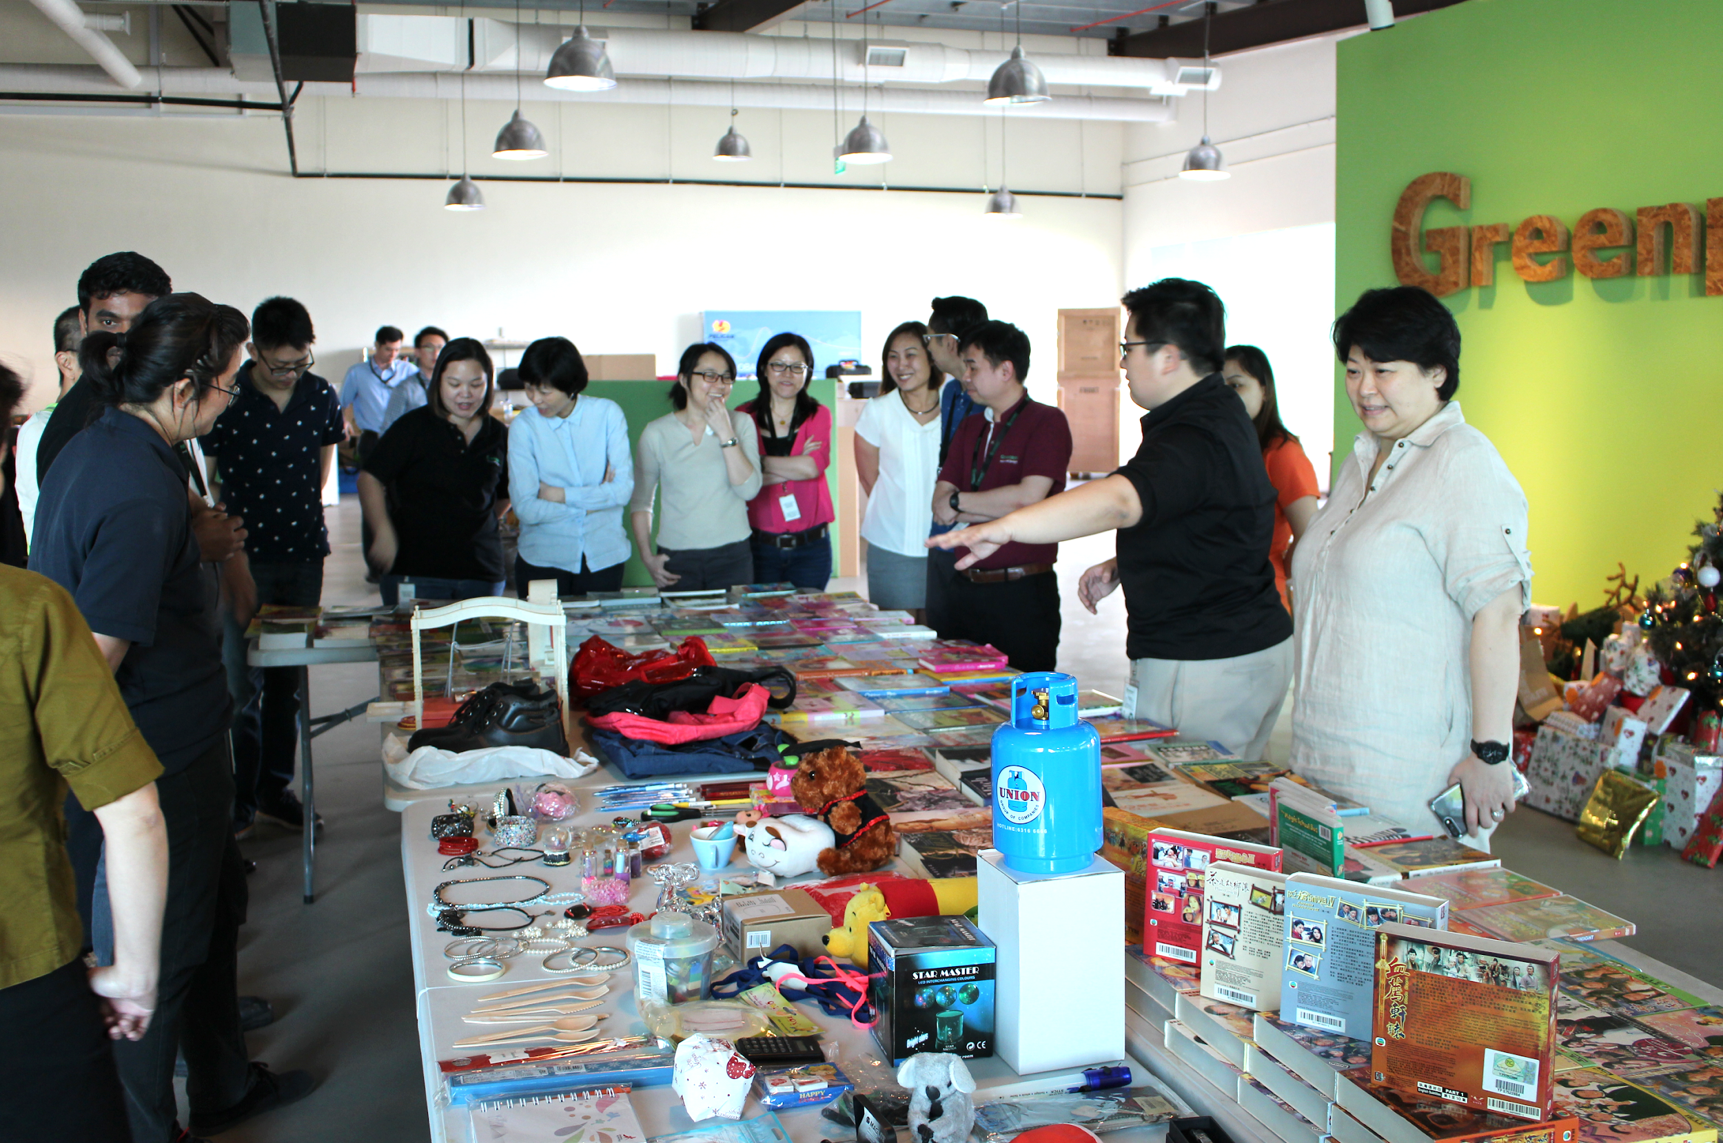

Hydroponics Farm in Greenpac's Office

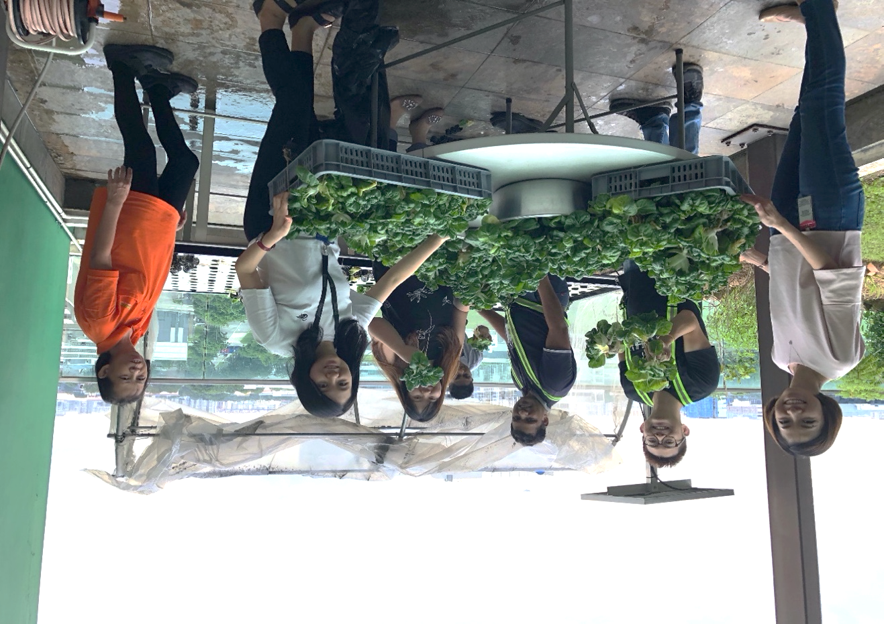

Exhibit 8 (continued)

Distribution of Vegetables from Hydroponics Farm, with Juying Primary School

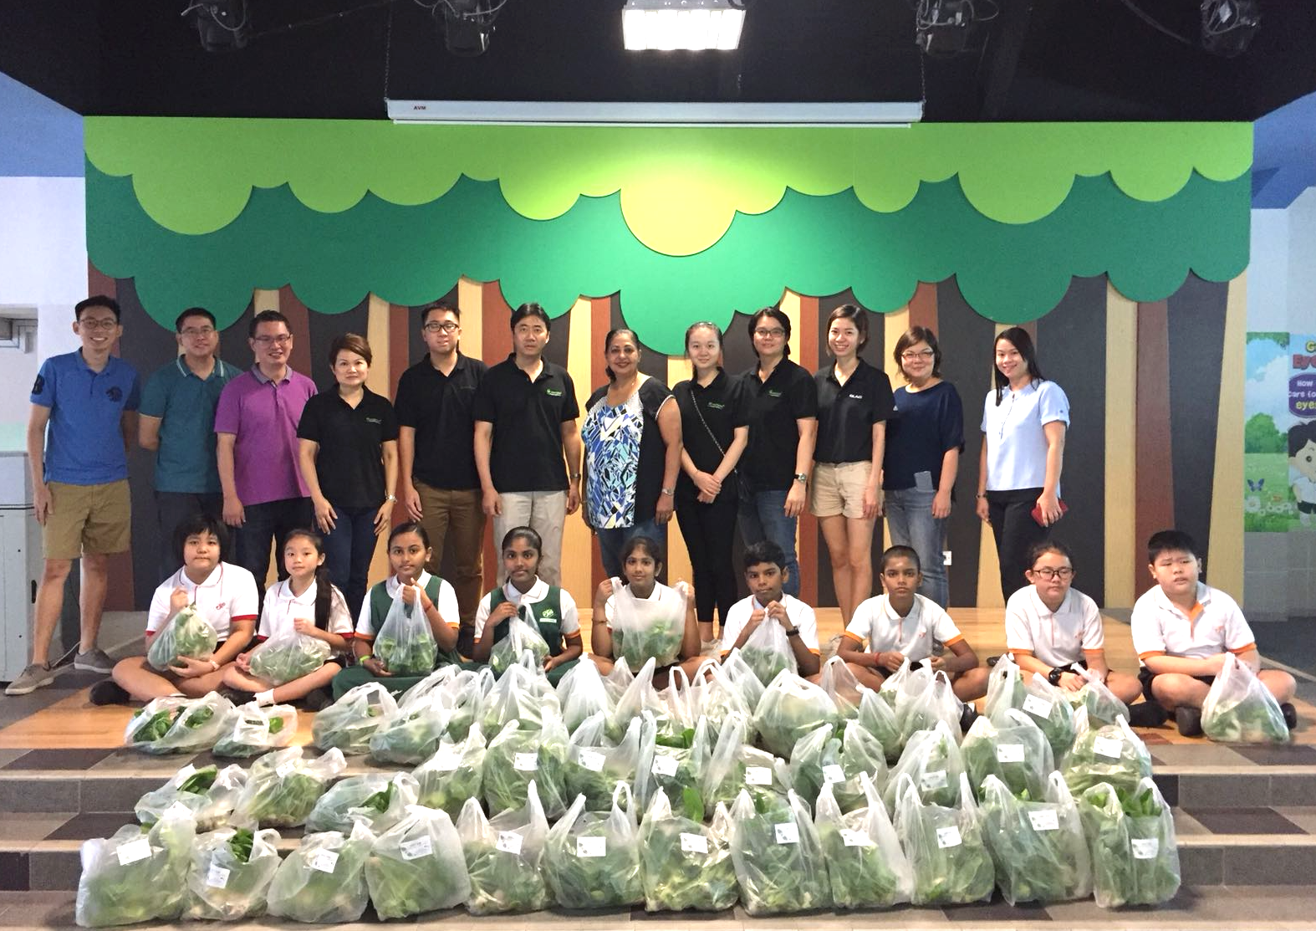

Internships for Secondary School Students at Greenpac

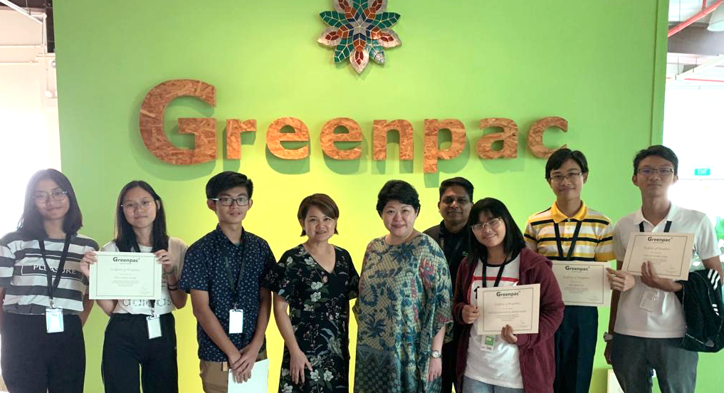

Source: Company files.

1. Forest Stewardship Council, accessed January 14, 2021, https://fsc.org/en.
2. "Frequently Asked Questions," Salvation Army Singapore, accessed November 18, 2019, https://www.salvationarmy.org/singapore/frequently_asked_questions.
3. Chia Yan Min, “30-Member Committee Assembled to Plot the Future of Singapore’s Economy,” *Straits Times*, January 19, 2016, https://www.straitstimes.com/politics/30-member-committee-assembled-to-plot-the-future-of-singapores-economy.
4. “Who We Are,” Yellow Ribbon Project, accessed January 14, 2021, https://www.yellowribbon.gov.sg/community-engagement/yellow-ribbon-project.
5. Assaad W. Razzouk, "Green Steps That Singapore Should Take Urgently," *Today*, September 30, 2019, https://www.todayonline.com/commentary/how-singapore-can-help-prevent-climate-change-instead-spending-s100-billion-adapting-it.
6. Ministry of the Environment and Water Resources, *Zero Waste Masterplan: Singapore* (Singapore: Ministry of the Environment and Water Resources), accessed January 14, 2021, https://www.towardszerowaste.gov.sg/images/zero-waste-masterplan.pdf.
7. “Practice Note 7.6: Sustainability Reporting Guide,” Singapore Exchange Limited, accessed October 31, 2019, http://rulebook.sgx.com/rulebook/practice-note-76-sustainability-reporting-guide.
8. Zhang Weina and Ruth Tan, “What is Sustainability Reporting?,” *Straits Times*, September 22, 2019, https://www.straitstimes.com/business/invest/what-is-sustainability-reporting.
9. “About Company of Good,” Singapore Company of Good, accessed February 17, 2021, https://www.companyofgood.sg/about.
10. “GMI Ratings,” *Business Insider*, accessed April 22, 2019, www.businessinsider.com/author/gmi-ratings.
11. Lawrence Loh and Thomas, *Sustainability Reporting in Singapore* (Singapore: Centre for Governance, Institutions and Organisations, National University of Singapore Business School, November 2018), https://bschool.nus.edu.sg/cgio/wp-content/uploads/sites/7/2018/11/ACN-CGIO-Sustainability-Reporting-in-Singapore-2018.pdf.